PREAMBLE

Cocaine Anonymous is a fellowship of men and women who share their experience, strength and hope with each other, that they may solve their common problem and help others to recover from their addiction.

The only requirement for membership
is a desire to stop using cocaine and all other mind-altering substances. There are no dues of fees for membership; we are self-supporting through our own contributions. We are not allied with any sect, denomination, politics, organization or institution. We do not wish to engage in any controversy and we neither endorse nor oppose any causes. Our primary purpose is to stay free from cocaine and all other mind-altering substances, and to help others achieve the same freedom. *

We use the Twelve Steps of Recovery because it has already been proven that the Twelve Step Recovery Program works.

(*Reprinted and adapted with permission of AA Grapevine, Inc.)

Southern AB Area of
Cocaine Anonymous
1-833-762-3700
ca-ab.org

World Service Office of
Cocaine Anonymous
1-800-347-8998
ca.org

PHONE NUMBERS

COCAINE
ANONYMOUS
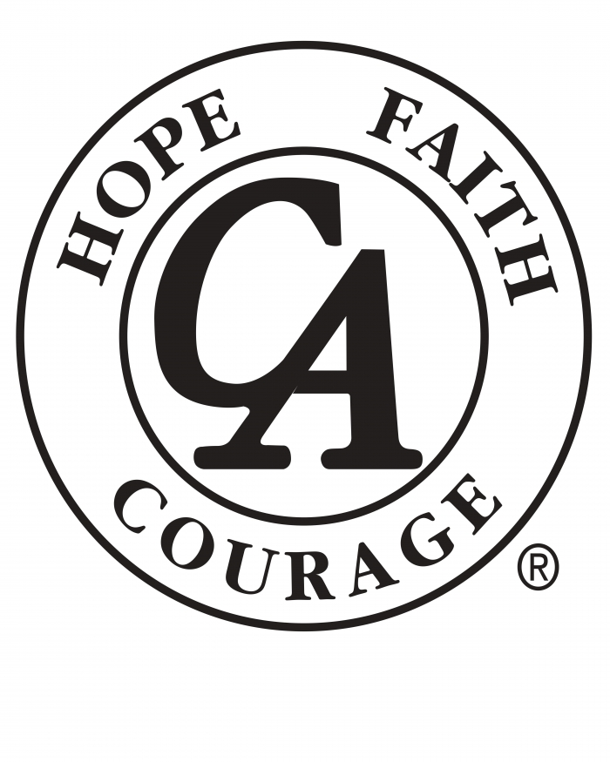
“We’re Here
and
We’re Free”

District
of
Medicine Hat, AB

“HOPE DEALERS”
Autism Respite Centre
337 - Division Ave N
WEDNESDAY @ 7:30 pm

“WHERE HOPE BEGINS”
Alano Social Club
466 Macleod Trail SE
SUNDAY @ 5:30 pm

